**TEST EVIDENCE |** [**SECURITY-1**](https://snehalwagh2121.atlassian.net/browse/SECURITY-1) **| CREATE A PROJECT FOR SPRING SECURITY**

***Summary:***

Create a sample spring security project and specify how to authenticate a user and allow users with specific roles only to access certain api’s.

***TEST EVIDENCE:***

Logic which will take care of authentication:

@Override  
public Authentication authenticate(Authentication authentication) throws AuthenticationException {  
  
 CustomUserDetails u = userDetailsService.loadUserByUsername(authentication.getName());  
 if (u != null) {  
 if (passwordEncoder.matches(u.getPassword(), authentication.getCredentials().toString())) {  
 return new UsernamePasswordAuthenticationToken(u.getUsername(), u.getPassword(), u.getAuthorities());  
 }  
 throw new  
 BadCredentialsException("External system authentication failed");  
 }  
 throw new  
 BadCredentialsException("External system authentication failed");  
  
}

Logic which will take care of authorization:

@Override  
public void configure(HttpSecurity http) throws Exception {  
 http.authorizeRequests()  
 .antMatchers("/demo/admin")  
 .hasAnyAuthority("ADMIN")  
 .antMatchers("/demo/manager")  
 .hasAnyAuthority("ADMIN", "MANAGER")  
 .antMatchers("/demo/user")  
 .hasAnyAuthority("USER", "MANAGER", "ADMIN")  
 .anyRequest().authenticated()  
 .and().formLogin();  
}

User’s details:

INSERT INTO Users(username, password, role) VALUES ('snehal','pass','USER');

***Snapshots of test:***

Page prompts to login as soon as we hit the admin or manger or user api:

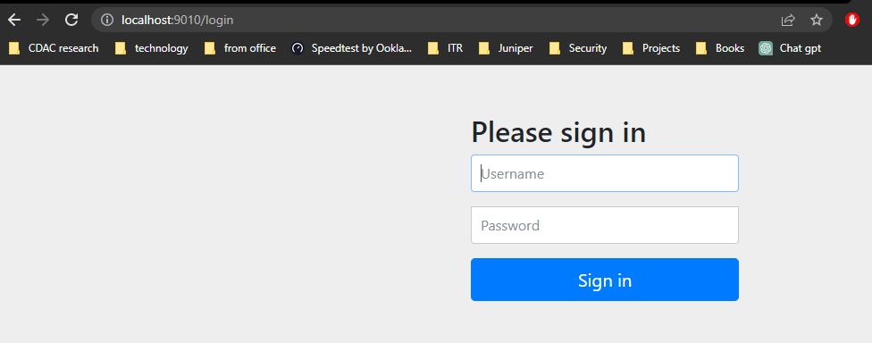

Enter credentials:

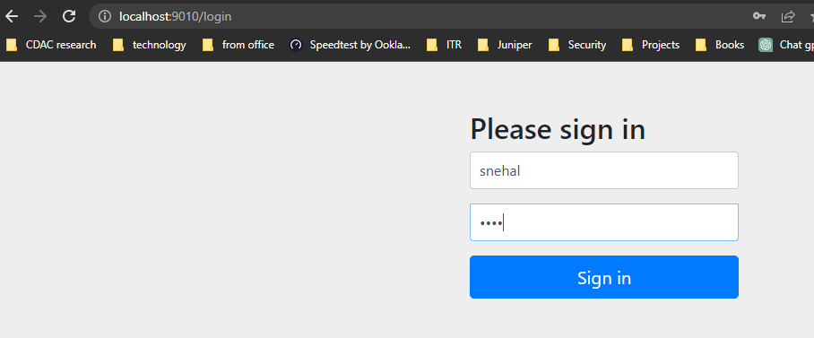

Since we have requested for admin page and the user has role USER so he will be restricted to access the page. Same with admin page for user: snehal

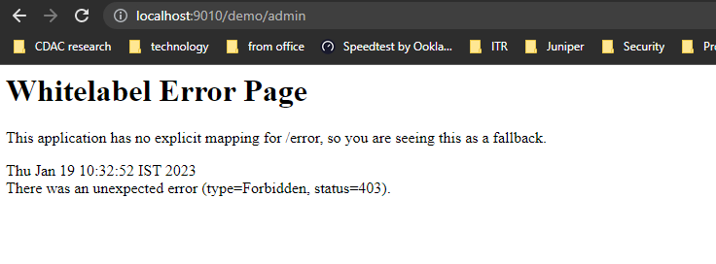

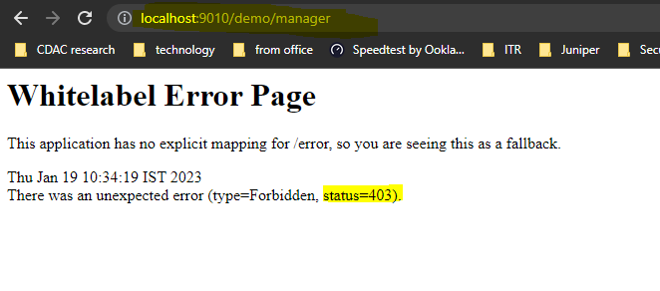

But the user is able to access the user page:

